PUNE DISTRICT EDUCATION ASSOCIATION’S
SETH GOVIND RAGHUNATH SABLE COLLEGE OF PHARMACY
SASWAD, DIST-PUNE
Report of Annual Social Gathering ‘AGAZ’ Cum Annual Prize Distribution Ceremony 2021-22
( 30/04/2022)
The institute has celebrated different Days like Twins day, mismatch day, western day and retro day as a part of celebration of Annual Social Gathering from 26th April- 27th April 2022. The Traditional day was celebrated on 29th April 2022 in the morning session. The students of all classes have shown their performances of tradition one by one. The traditional day was coordinated by Mr. Vaibhav Shilimkar, Mrs. Vishakha Gaikwad, Ms. Vishakha Jagtap and Ms. Sunita Bathe.

The fun-fair was organised in afternoon session at 2.00 p.m. on 29th April 2022 in the back space of open stage. Around 17 stalls of food and funny games were arranged in the SGRS Fun-fair. Mr. Jitendra Shinde, Ms. Jayashri Nale and Mr. Hanumant Patil coordinated successfully SGRS fun-fair program.

The college organized Annual Social Gathering ‘AGAZ’ and Annual Prize Distribution Ceremony 2021-22 on 30/04/2022 in the College Campus. The Annual Prize Distribution Ceremony began at 11.00 a.m. under the able guidance of Principal Dr. Rajashree Chavan. Hon. Adv. Sandeep Kadam, Hon- Secretary, PDEA was the chairperson, Hon. Bipin Tilekar, Sr. Technical Officer, ICMR National Institute of Virology, Pune was the chief guest and Hon. Dhanshree Lomate, Bharatnatyam Teacher, Saswad was the guest of Honour for this function. The program commenced with lamp lightening and Saraswati poojan at the auspicious hands of Hon’ble chairperson and chief guest. Thereafter Principal Dr. Rajashree Chavan delivered preamble and read the Annual college report highlighting the main achievements of the college and its steady progress towards higher aims and standards in education for all-round development of students. The Principal in her speech appreciated the students for their performances, followed by the speech of all guests and chairperson.

Toppers of D. Pharm., B. Pharm. and M. Pharm. were awarded by trophies, books, cash prize and certificate for their achievements in academics and for sports, cultural and various other extra-curricular extraordinary achievements all successful students honoured by trophies and certificates. The chairperson and Chief Guest gave away the prizes to the meritorious students in academics, sports and cultural events. The formal function culminated at 2.15p.m. with vote of thanks proposed by Prof. Jayashri Jagtap, Cultural Incharge followed by national anthem. The program was compered by Prof. Sagar Bhise and Prof. Payal Borawake.

The cultural events began at 4.30p.m. with Ganesh Vandana by the T. Y. B. Pharm. students followed by Solo dance, duet dance, group dance, drama, cocktail, mime singing etc. More than 200 students participated in Annual function, all were very enthusiastic to enjoy every moment of it. The Annual function was concluded at 8.30 p.m. with national anthem.

The Annual day cum prize distribution ceremony successfully coordinated by Prof. Jayashri Jagtap, Cultural Incharge, Prof. Payal Borawake cultural Incharge (D. Pharm.) and Prof. Ashwini Kunjir, Cultual Incharge (Poly).

Photo Gallery

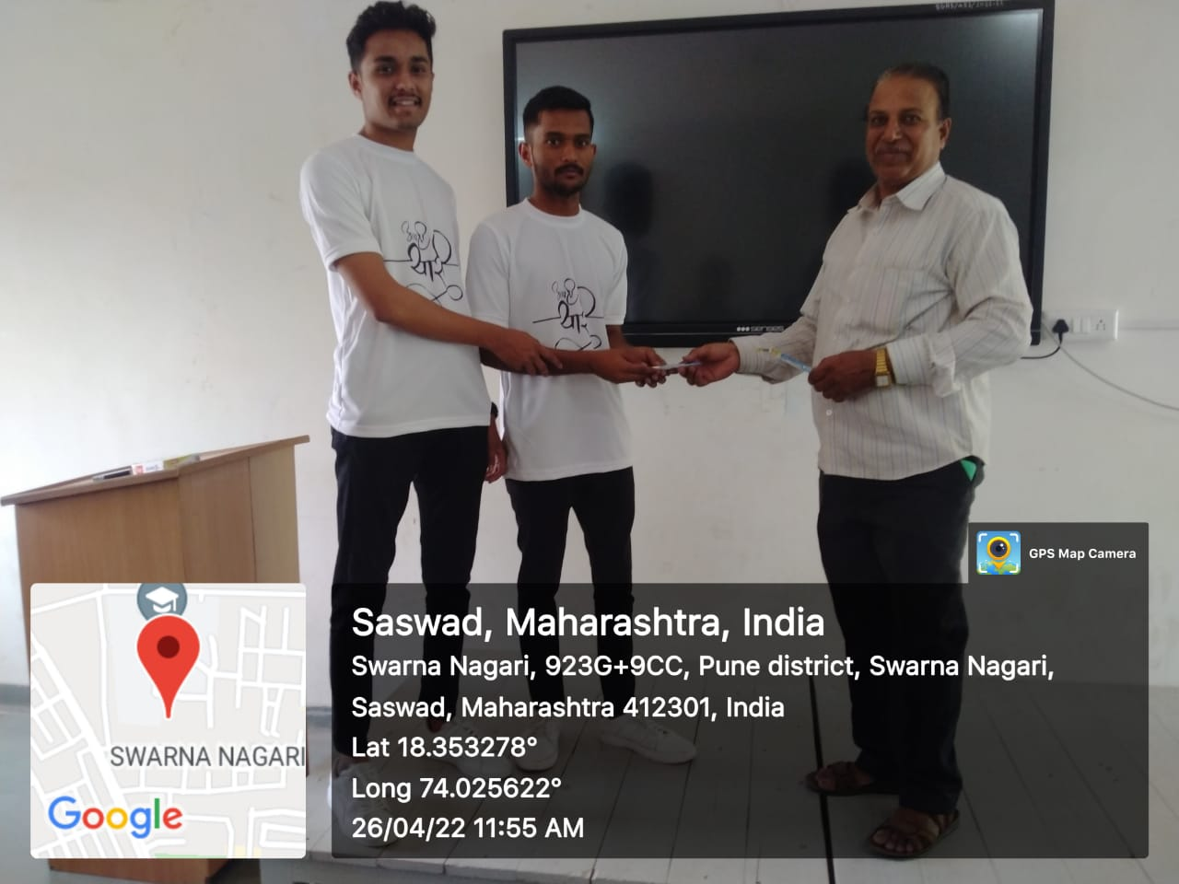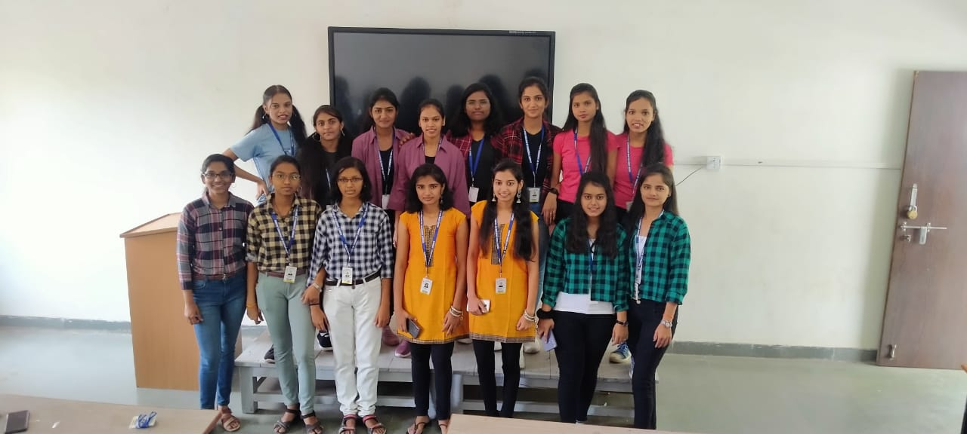
Days Celebration

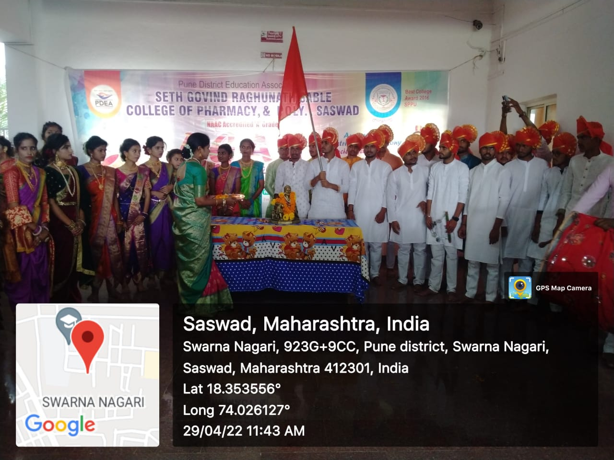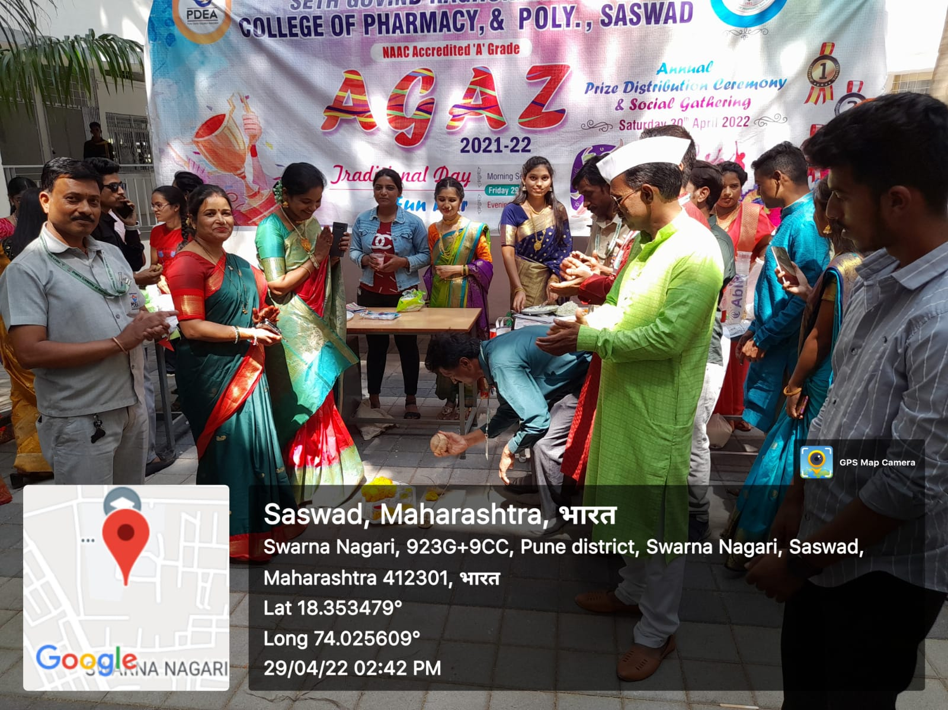
Traditional Day Fun-fair Day

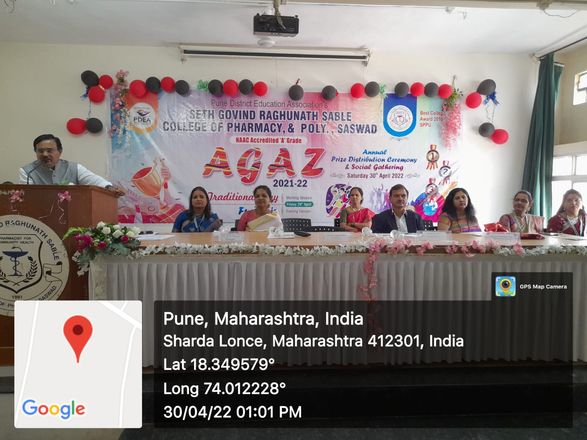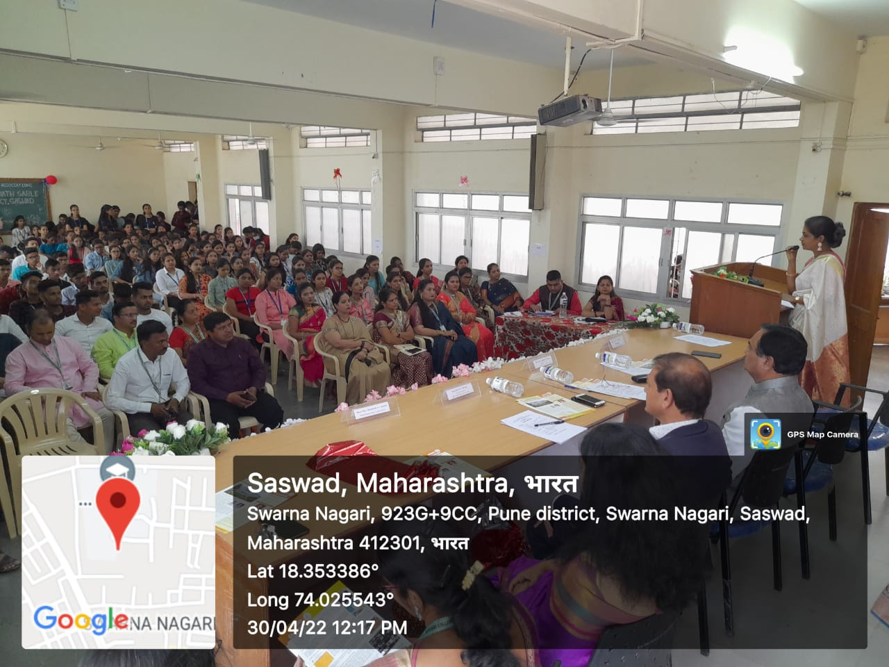
Annual Prize Distribution Ceremony

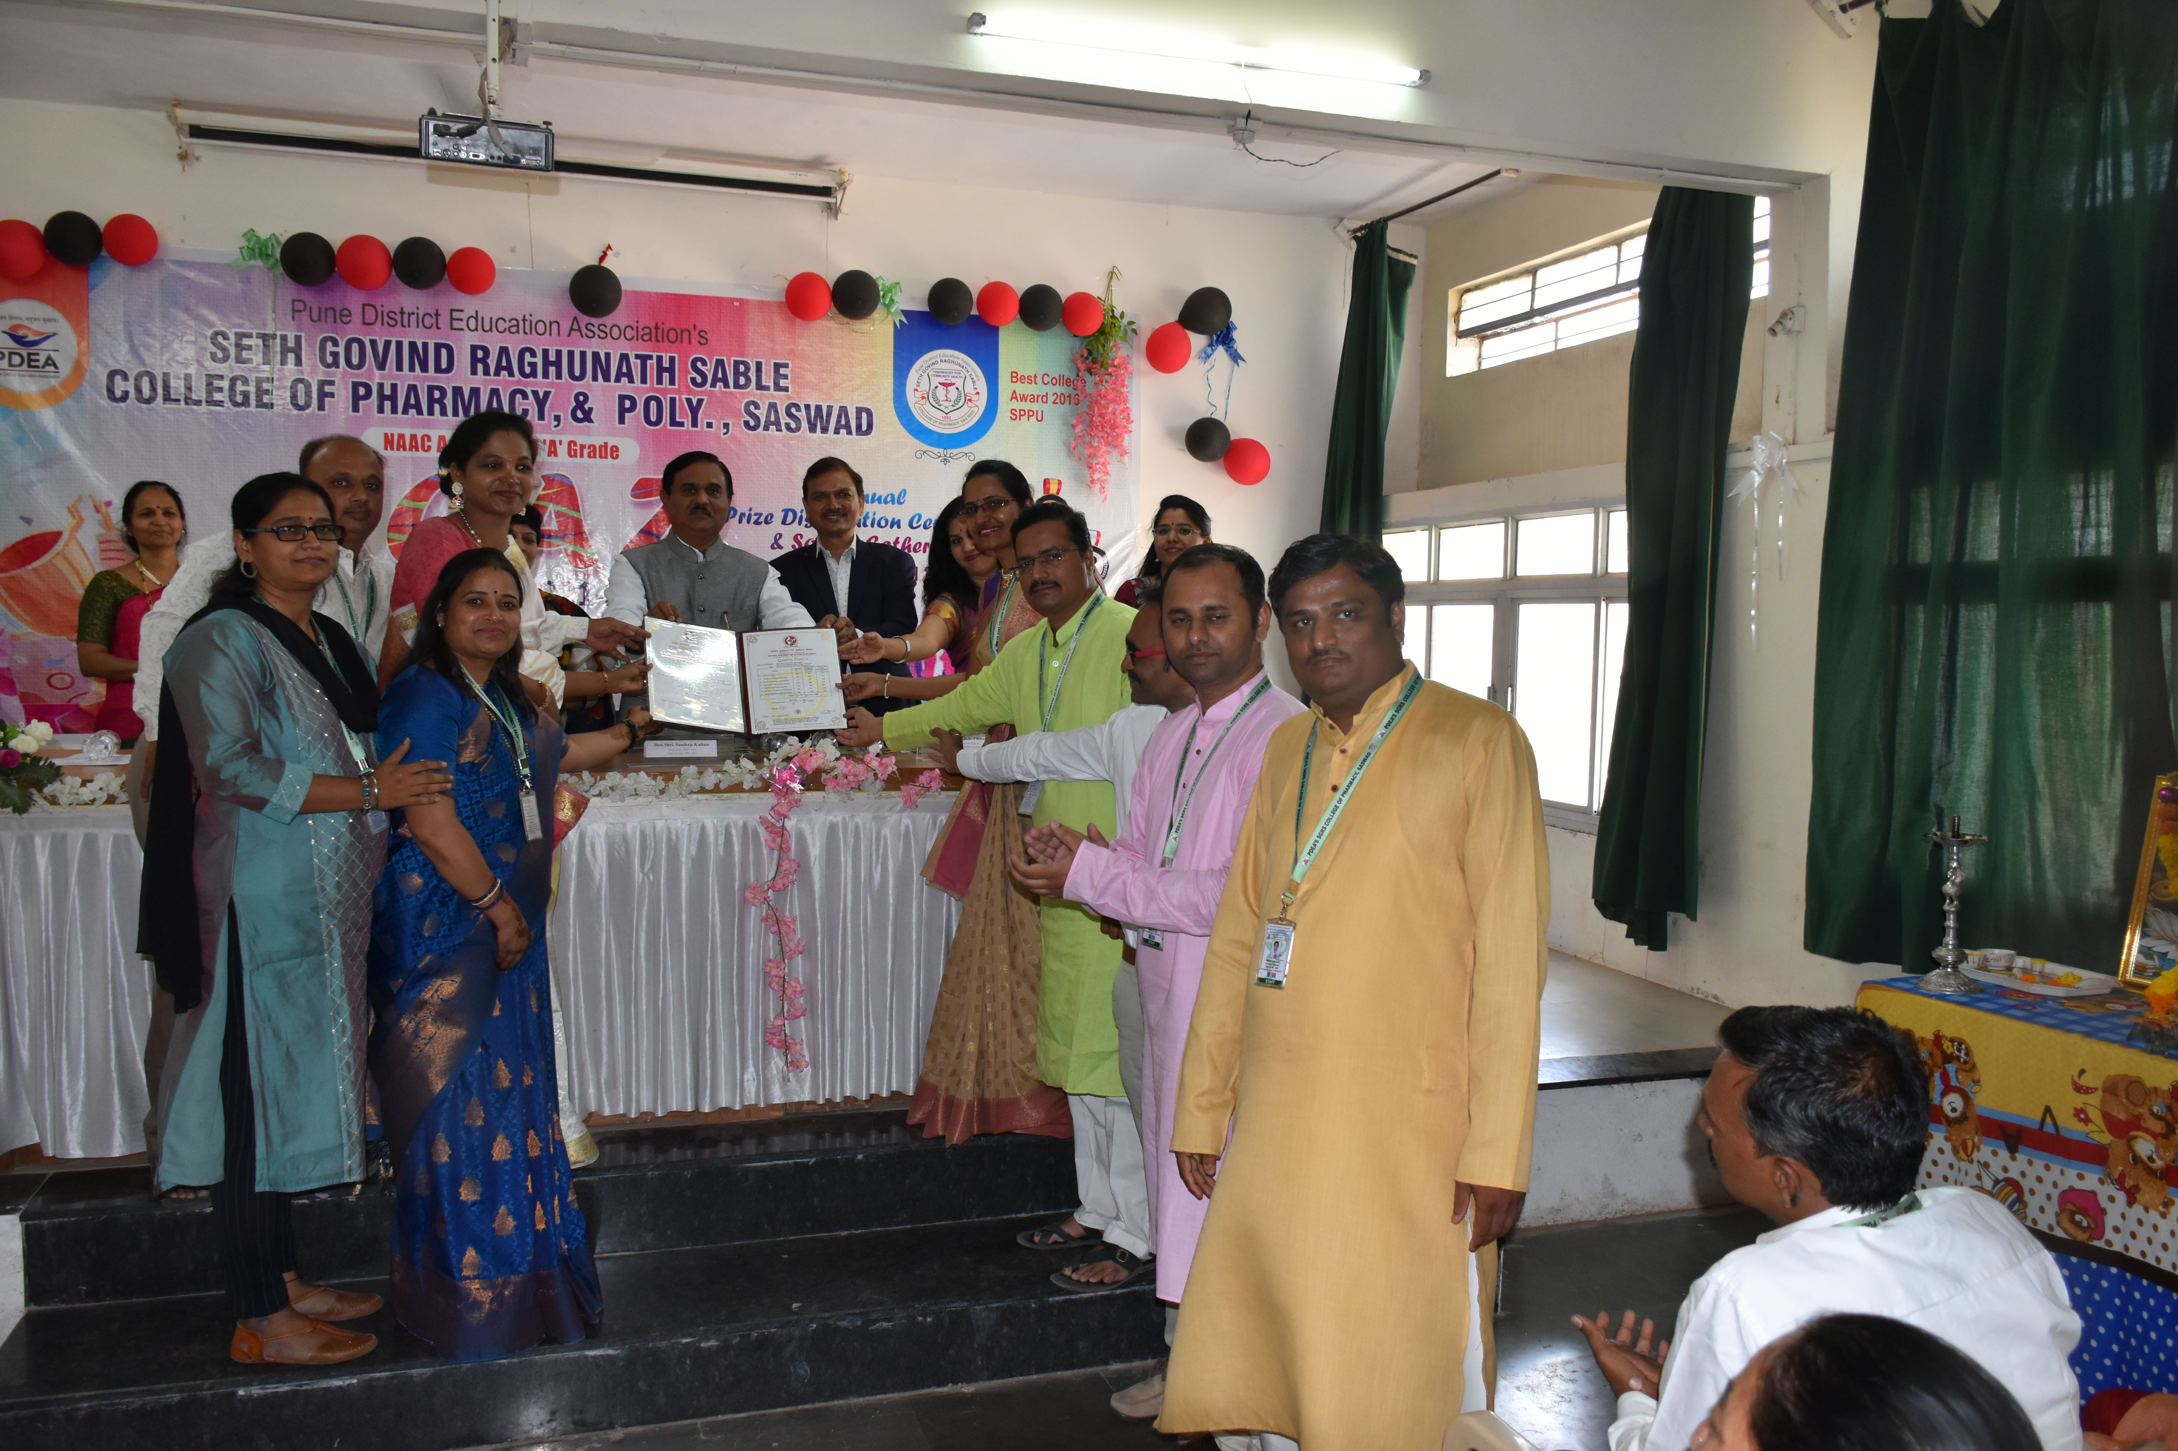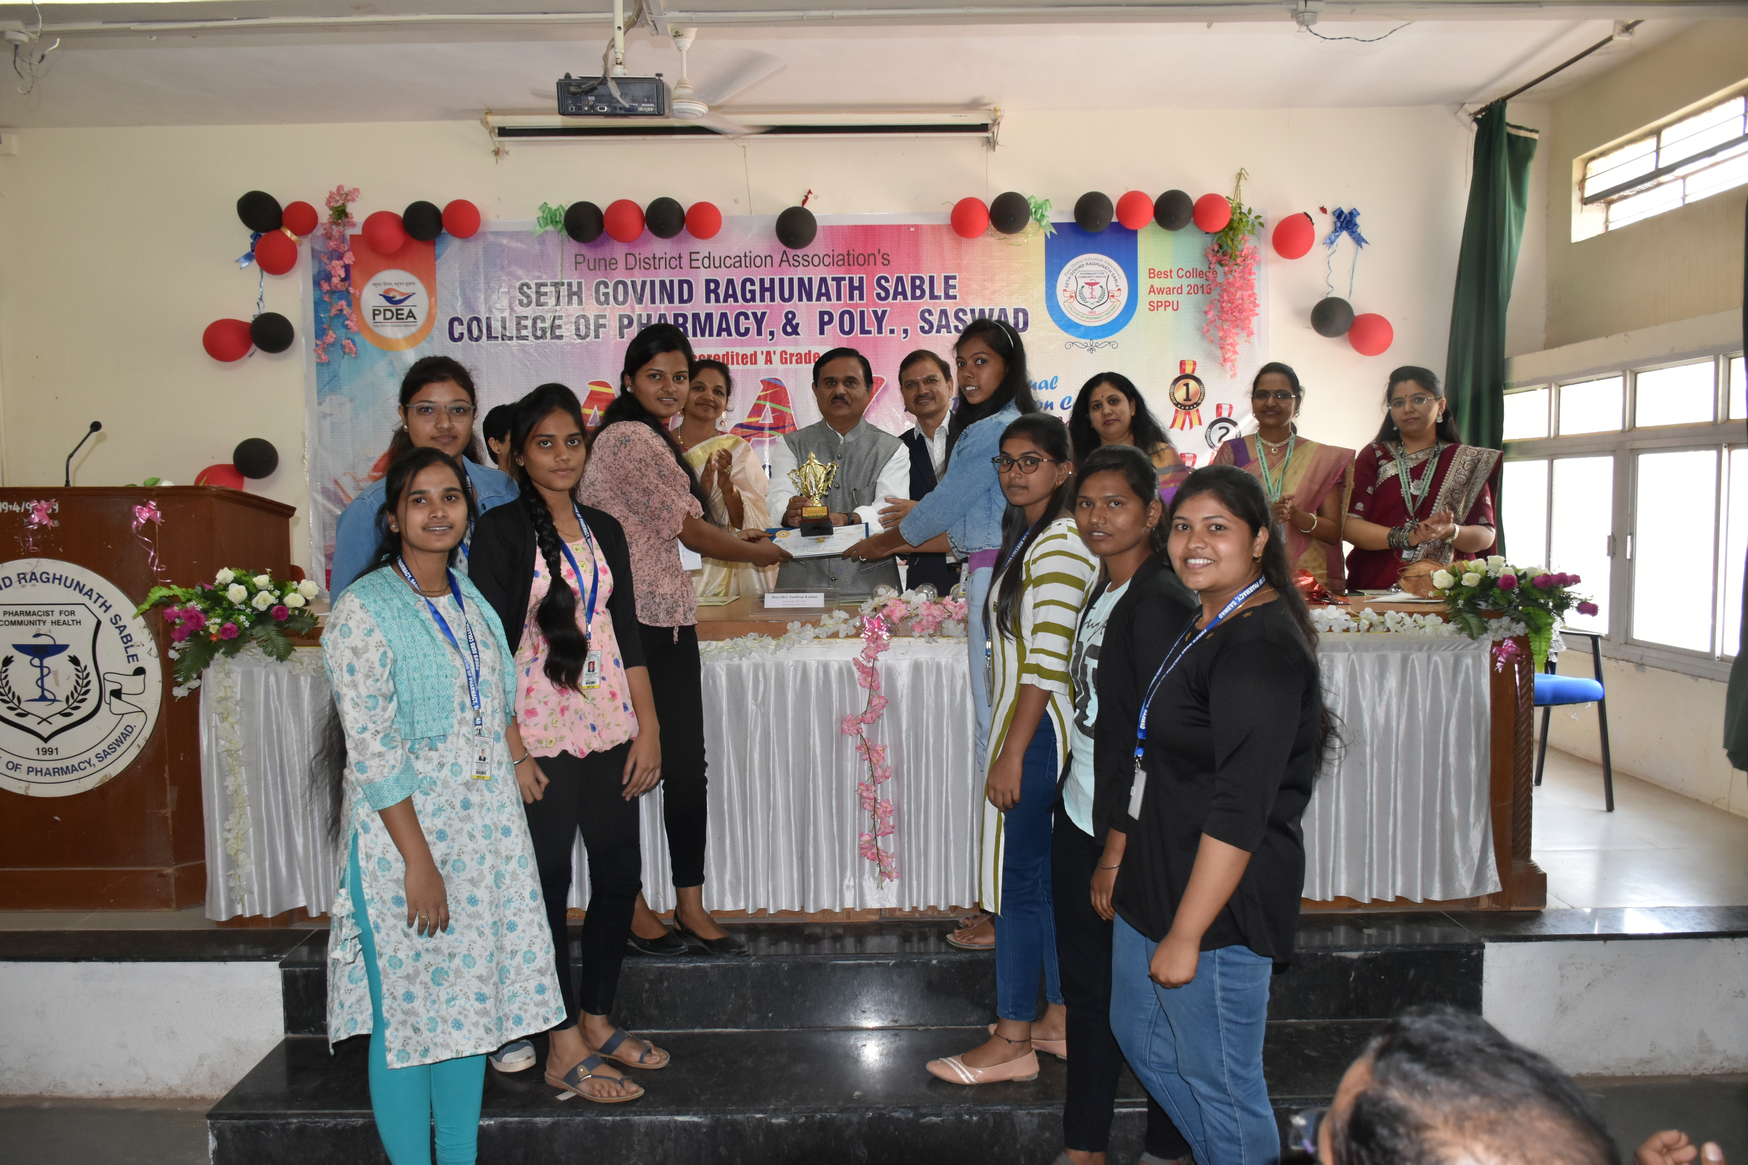

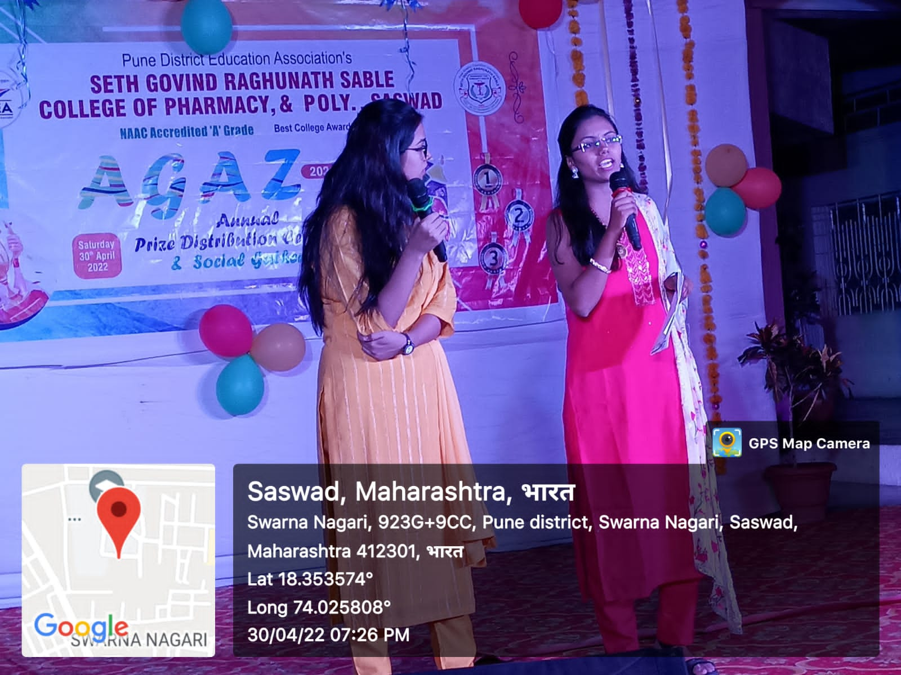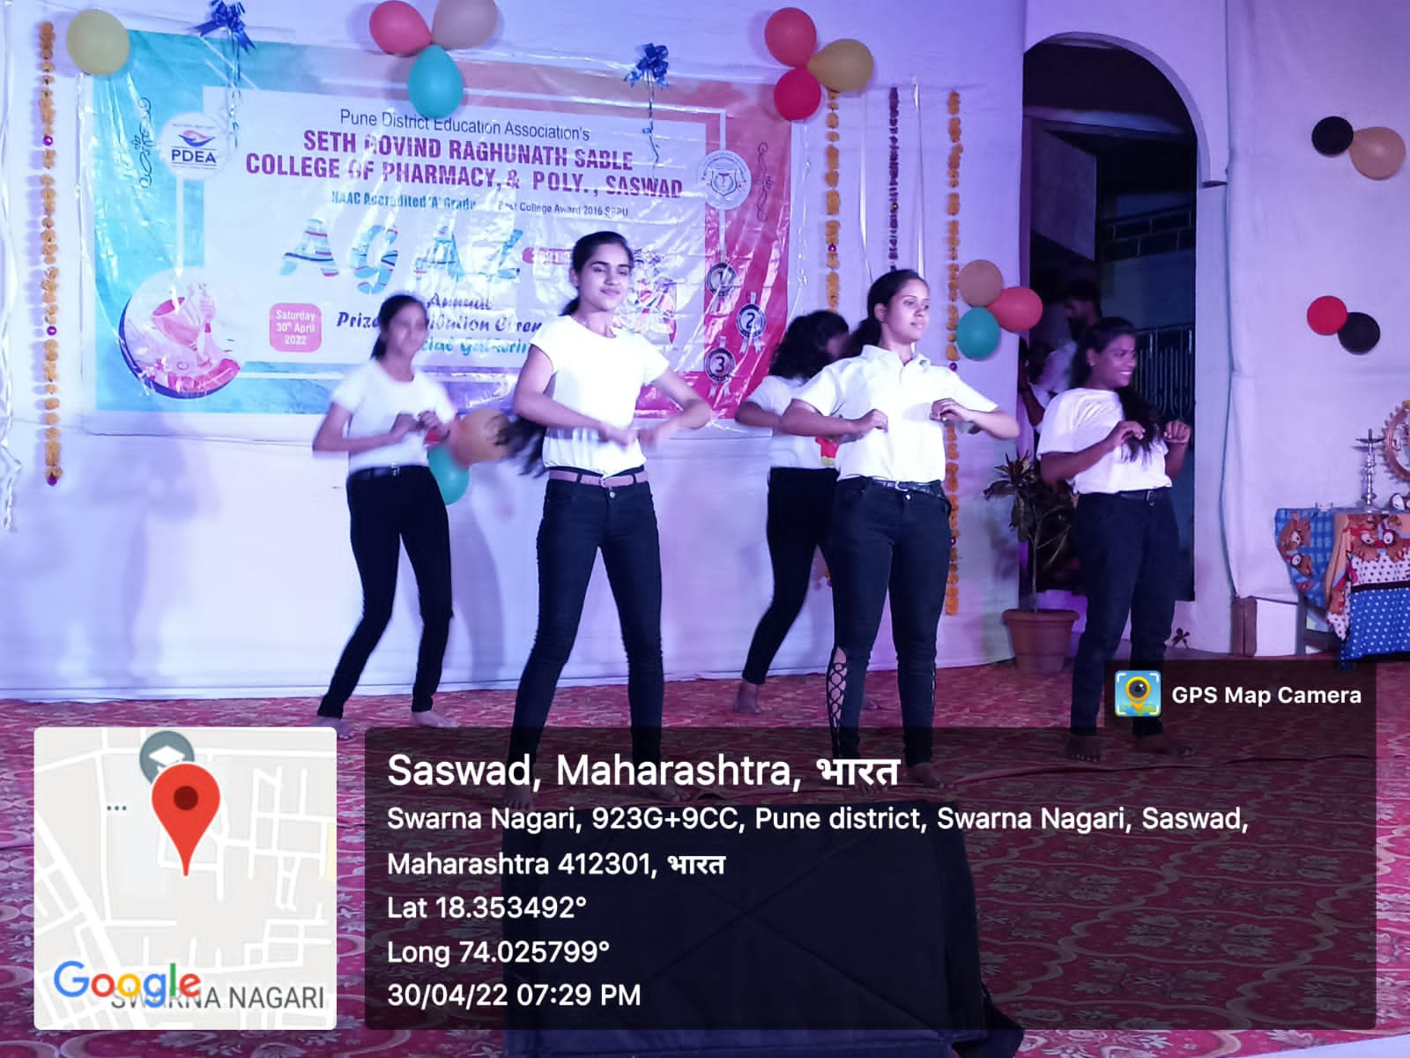
Annual Social Gathering: AGAZ

